K0012473

Max Pears

Games Practical Project

COM3045-N-BJ-2013

Contents

Title ……………………………………………………………………………………….Page 3

Outline Description………………………………………………………………………Page 3

Rational for Choices ……………………………………………………………………Page 3

Areas for Investigation …………………………………………………………………Page 3

Methodology……………………………………………………………………………..Page 3

Research Ethics…………………………………………………………………………Page 4

Literature review…………………………………………………………………………Page 5

Project deliverables……………………………………………………………………..Page 5

Schedule …………………………………………………………………………………Page 5

Background Research ………………………………………………………………….Page 6

Bibliography ……………………………………………………………………………..Page 10

Title: Project Fairy Tale (working title)

Outline Description: I intend to create a fast pace platformer/endless runner for android devices. Using the touch inputs for creating a fun, addictive experience which will make players want to come back for more.
The player will take one the role of a knight who is making their way through a dungeon to find treasure. However the knight is being chased by a dragon who is trying to stop him by shooting fireballs to destroy him and his path.

Rationale for Choices: Inspirations for this game are from multiple sources such as fairy tale characters and Disney films, these characters and worlds interest me as they were huge part of my childhood. I want to take those worlds off the pages and evolve them so they have that same affect with new technology, for a new generation.
After carrying out my work placement I learnt how to create mobile games and have a better understanding of how they work, as well as what makes a good mobile game. I learnt how to program over that year as well so I want to learn more C# and improve as a game developer. If this game reaches a high standard I believe it can help my portfolio as well as making me stand out from other candidates.

I believe that no other game in the genres (mentioned above) have an enemy constantly and visibly chasing the player or interacts with the player/level like this. This makes it a key selling point. The UK is becoming much more popular for indie studios; I want to know how able I am to create a game by myself. More and more developers are using Unity so I want improve my skills with Unity to make me more employable.

Areas for Investigation: To create a great project I will need to investigate multiple areas to help me achieve my goal. Areas I will be investigating are:
- What makes a good mobile game
- How to design for casual players.
- How I can make the game gender friendly?
- What makes a successful mobile game?
- C# and javascript
- How to get the best out of the Unity engine and all its plugins such as Uscript, NGUI, etc.
- New ways to design with a touchscreen device.
- Which engine is the best for mobile devices?
- Optimising for mobile devices.
- How much of an impact have mobile games had on the industry?
- How often people use their mobile devices?
- Why this genre is so successful?
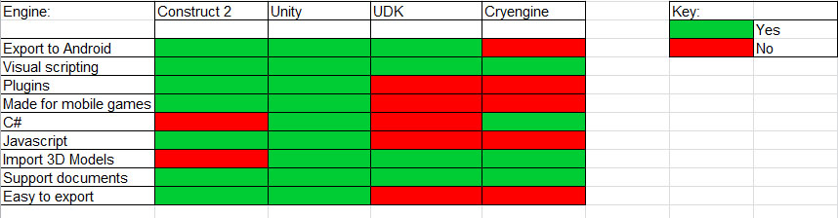
Methodology: My objective throughout the project will be to create the game so this will mean programming and designing the levels and HUD, etc but my main focus is the gameplay. How I will be creating the game play is through scripting elements such as C#, javascript, or through visual scripting. I have been looking at which game engines will allow me the freedom as well as the ease of porting to android.

I had been thinking about creating some of the assets myself as I would feel more connected and be able to create what I imagined. Looking over my asset list it would take way too long and would distract me from focusing on the game play.

I am thinking outsourcing the assets and animations, as it will be quicker for me to create the overall game experience. I will be crediting the artist and animators who will provide me with their work. This will also cut down development time which should result in quicker development time as well as providing a buffer for me if I have problems with any of code or bugs.
Asset List: | Art | Sound | Code | Design | Animations
 | Dragon | Collisions | Following AI | Design Doc | Knight run
 | Fireball | Fire breathing | Firing fireballs | Level 1 | Knight Jump
 | Smoke fX | crash | run and jumping | Level 2 | Knight charge
 | Wall Variation 1 | gem pick up | Touch inputs | Level 3 | Knight crouch
 | Wall Variation 2 | life losing | HUD's | HuD design | Knight dance
 | Wall Variation 3 | Main theme | Pickups | Sound design | Dragon arriving
 | Wall variation 4 | Menu theme | Health system | Game play | Dragon attack
 | Floor panel 1 | Buttons pressed | GUI |  | Dragon Idle
 | Floor panel 2 | Victory sounds | Main Menu |  | Dragon death
 | Floor panel 3 | Death sounds | Charging |  | Dragon victory
 | Floor panel 4 | Orc attacking | Breaking through doors |  | Orc idle
 | Pillar 1 | Orc dying | Orc health |  | Orc attack
 | Pillar2 |  | Orc damage |  | Orc death
 | Pillar3 |  | Destroying environment |  | Orc victory
 | Orc |  | Finish script |  | Chest opening
 | Door1 |  | Death Script |  | Pillar falling
 | Door 2 |  |  |  | Platform falling
 | Door 3
 | Door 4
 | Candle 1
 | Candle 2
 | Candle 3
 | Candle 4
 | Lanter 1
 | Lanter2
 | Lanter 3
 | Skybox
 | Chest
 | Dimond
 | explosion fx
 | Pick up fx
 | Hud assets

Research Ethics: I have come across a few ethical choices in my research which have impacted my design choices. One was after I watched a youtube video series called ‘tropes vs women in video games’, this changed my opinion on a few way women were portrayed. In my original idea the knight would save the princess but this can be stated as sexist so the motive would be greed as the Knight wants the treasure.
I will be testing the game on all kinds of people such as male, female, old and young. I know I will have to get permission from children’s parents/guardians. The environment that participants will be testing in will be by themselves and I will just be watching them to see if they understand what they need to do, as well as asking for feedback.

Literature review: One of the books I will be looking at is Appilionsaires which is about the journey and process of some of the successful app developers and how they carried out their work [16]. As I would like to create 2 levels of quality I will be looking at a book by a great designer called Phil Co, this book is over 6 years old but what he says still has meaning today. He has been working in the industry for a long time as well as working for one of the best game companies in the industry, this why I feel his work is still valid [17].

Gamasutra is constantly being updated by professionals who help one another improve their work. One of their articles from Ubisoft is brilliant as it talks about the whole design process. Members will talk about what they do and the experiences they are having [18]. Clifford Bleszinski is a legend in the gaming industry that also has a blog which talks about games, his view on design and how to improve it. I think this will be a great insight for design and how to improve [19].

If I decide to use Unity then it has a scripting reference with lots of details which will help me with any scripting problems [20].

Project deliverables: The product I intend to deliver at the end of this time frame is an almost complete game. This mobile game will be running correctly on an android tablet with all touch controls working. Sound and HUD will be implemented as well.
There will only be 2 levels in the game, this is because of the time period if I were to continue the project after the deadline, more levels would not be hard to create because all of the key features will be implemented. ‘Project Fairy Tale’ will be an addictive game with a quirky art style and the unique selling point of the Dragon and his effect on the area.
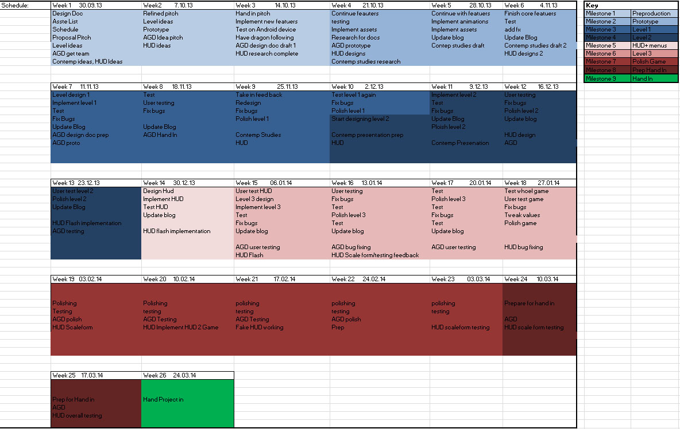
Schedule: (Visit Asset + schedule excel to see in more detail)
Background Research:

Why Choose Smartphones as the target platform?
First of all, why choose smartphones?
After carrying out a year placement in FOG (Free Online Games) I spent most of my time making apps for iOS and Android devices so I feel that I have gotten a better understanding on how to design games for the casual market as well as seeing how big the market has become.
Mobile and tablets have also become much more essential to modern day life as a majority of people own a smart phone or a tablet. Which means ease of access for the user is much higher than a console because they are apart of everyday life.

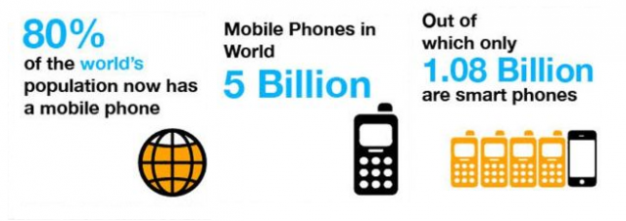
“Mobiles are now an essential of day to day life as we know”, according to Helena, Onbile [1]

[1]

This is a huge market for a game to be played on that is a bigger market than the top selling game console which according to sales figures was the Nintendo DS with “153.67 million units sold” [2]

The number of smart phones is 6.5 times larger than the number of units of the best selling console which means my game can reach a much bigger target audience as well as having higher sales figures. This is interesting as it means there is more potential to reach more of an audience by using these devices.

There is already a big market for apps and games companies are taking notice of this as well. Garth Edwards from ThumbStar studio gave a talk at Game Horizion [3] said “There are 12 billion phone games out there and that smart phones are 32% of the mobile phone market.”
This shows that there is a wide enough market for my game app as well as a broader and bigger audience too, however is there a profit to be made as games are still a business.

Apps are becoming one of the quickest selling virtual items and are constantly growing.
Canalys says “that in 2011a total profit of app sales was $7.3 Billion. Canalys . (2013), App Stores’ direct revenue to exceed $14 billion next year and reach close to $37 billion by 2015” [4]
This shows that if my product has potential and is made to a high standard then there could be potential for me to continue working it after university as well as maybe make a living from this as well like others.

Another reason for developing on mobile phones is for the fact that many people to do are carrying them with them constantly an use them on a daily basis at least. People always have access to their phones so having an app on their phone will be easier to access than having to put a hard copy of a game than a console.

“9 out of 10 people use their mobile phones a day.” [5]
“The average American spends 619 minutes/month on the cell phone, that's 20.5 minutes/day and 78% of Americans have a cell phone.” [6]

Smartphones constantly keep improving at impressive rate; their specifications get better each year. Ranging from iPhones to Samsung’s.
Looking at the Samsung Galaxy S3 specifications shows that it is like having a small PC in your hand. It has 1GB of RAM, 720 HD display, Multi-Touch, Quad core processor, up to 64GB Micro SD memory card. Gsmarena,[7].
Now the iPhone 5 has been out for a few months as well right now and is one of the most popular and top speced phones out there. Capacity : 16, 32, 64GB. Display: Rentina display, 1136 x 640 resolution 326 ppi, Multi-Touch display. Sensors: Three-axis gyro, Accelerometer, Proximity sensor, Ambient light sensor. Processor: 1.02GHz dual-core A6 chip. [8]
Looking at the specs of these two phones it is easy to see that there is a lot of power in the top of the range phone which means that games on our phones are getting better with their graphics and mechanics.

As you can see by my research smartphones and tablets are popular as well being used constantly by their users. Technology in these devices are perpetually improving rapidly, and people are now making a living from creating games for mobile devices.

Why develop for mobile devices?

1) On placement my job was to make games for the app store as well as the Google for mobiles so I already have experience when it comes to making games for this plat form. Four of mine have been released as well. [9]

2)I have had experience developing for these type of platforms before. I feel that their input methods are interesting to design for using the touch input method, voice recognition, accelerometer, cameras. Four different input methods on one device will allow for interesting development opportunities. Phones can now connect with the internet which adds that competitive nature with games. Friends are competing with one another to get the highest score, greatest distance travelled, most collectables etc.

3) As most games on this market are casual games the design process is different as you develop a game which the player can keep revisiting. It has that re-playability value and the pick up and play factor. This is interesting as it is a different type of developing process compared to triple A games.
Anyone can pick up and play as well as giving them an addictive, fun, exciting experience anywhere, any time. Everyone can play so I am not isolating any particular audience. The games on the mobile market are casual games, this mean that the development cycle will a simple one which will allow me to meet my deadlines.
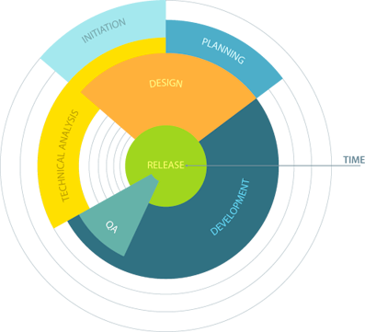
[10]

4) Publicity for releasing the game is not just based on money as the App Store's editors choice are chosen by the editors instead of something like XBLA. Which the developers have to pay $250,000 to be on the front page. A license to become an official developer on Apple is only $100 which lasts a life time. I mentioned earlier that I can continue with making a career by myself making mobile games.

What apps are popular on mobile devices?
There are all kinds of apps, available out on the App or Google store such as, entertainment, education, food, utilities, sport, etc. So why do a game and would it really bring in that much success?

The top paid app is ‘ Angry Birds’. The 2nd is Fruit Ninja 3rd Doodle Jump, there are 10 games in the top free over all iPhone downloads, as well as 7 apps from Top Paid iPhone chart are from the games category. 6 apps from Top Free iPad chart are from the Games category [11]. This just shows how popular games are in mobile market, I believe it is because people when waiting for an event such as a train or bus will kill time by playing games on the go. Data from that reference shows that games are now becoming more main stream more of popculture.
'In 2011 Apple released information on their most downloaded apps in America. The majority of the paid apps were in the game category' [12]. From my own personal experiences whenever I look at the top grossing catogry on the App Store a lot of the time it has been a game app.
Other popular apps which are free are normally either social network apps or tv apps such as BBC iPlayer, 4oD, and ITV Catch Up [13]. For the top paid section this has customizable layouts, widgets, radios or other tools for the android system [13].Mobile banking has increased over the past few years with most banks having an app for people to use to mange their accounts or Barcalys PingIt which is successful.

The impact mobile games have had on the gaming industry
With the increase of success that mobile games have had, they have had an impact on the industry. There has been a debate within the game industry for a few years now about casual games becoming bigger and more popular than hard core games. ‘Angry Birds and Temple Run, the casual games market I poised to become an $8.64 billion industry’[14]. With run away hits like Angry Birds and Temple Run they have helped to break the stereotypes of gamers being teenage boys, as '75% of casual gamers being women' [15]:

Bibliography:

[1] (2013) How many people use smart phones in the world [Online]
http://www.onbile.com/info/how-many-people-use-smartphones-in-the-world/
[Accessed 30 September 2013]

[2] Nintendo Co., LTD (1998/2013) Consolidated Sales [Online].
http://www.nintendo.co.jp/ir/library/historical_data/pdf/consolidated_sales_e1212.pdf
[Accessed 30 September 2013].

[3] Garth Edwards from ThumbStar Game Horizion conference on 27th June 2012

[4] Canalys 29 June 2011[Online].
http://www.canalys.com/newsroom/app-stores-direct-revenue-exceed-14-billion-next-year-and-reach-close-37-billion-2015
[Accessed 30 September 2013].

[5] Wiki Answers (2011), How many people use their cell phones a day, [Online].
http://wiki.answers.com/Q/How_many_people_use_cell_phones_each_day
[Accessed 30 September 13].

[6] Chacha (2012, June), How many times does the average person check their cell phone a day? [Online].
http://www.chacha.com/question/how-many-times-does-the-average-person-check-there-cell-phone-a-day [Accessed 01 October 13].

[7] (2013) Samsung Galaxy S3 Specification [Online].
http://www.gsmarena.com/samsung_i9300_galaxy_s_iii-4238.php#
[Accessed 01 October 13].

[8] Apple, (2013) iPhone 5 Tech Specs. [Online].
http://www.apple.com/uk/iphone/specs.html
[Accessed 01 October].

[9] https://itunes.apple.com/us/app/colin-cooper-racing/id589775912?mt=8
https://itunes.apple.com/us/app/high-rise!/id587409790?mt=8
https://itunes.apple.com/us/app/stans-parking-jam/id587418167?mt=8
https://itunes.apple.com/us/app/truck-challenge/id545606622?mt=8

[10] Social Cubix [Online].
http://www.socialcubix.com/services/game-development
[Accessed 01 October]

[11] Macstories, Fedrico Viticci( 03/03/2012) [Online].
http://www.macstories.net/news/apple-reveals-new-all-time-top-apps-following-25-billion-downloads/
[Accessed 03 October 13].

[12] Slashgear.com, Chris Davies (19th/01/2011) [Online].
http://www.slashgear.com/apple-reveals-all-time-top-app-store-apps-19127131/
[Accessed 03 October 13].
[13] Google Play Store[Online].
https://play.google.com/store?hl=en_GB
[Accessed 01 Oct. 13]

[14] Forbes, Jason Evangelho (01/02/13)[Online].
http://www.forbes.com/sites/jasonevangelho/2013/01/02/2012s-massive-casual-gaming-footprint-is-the-hardcore-audience-disappearing/
[Accessed 10 October 13].

[15] The High Tech Society, Brandy Cross (23/08/2013)[Online].
http://thehightechsociety.com/gamer-girls-women/
[Accessed 10 Oct. 13]

[16] Chris Stevens (28th October 2011)
Appilionairs.
1st edition.
The Atrium, Southern Gate, Chichester, West Sussex: John Wiley and Sons Ltd.

[17] Phil Co (8 Feb 2006)
Level Design for games, creating compelling game experiences,
1st Edition,
Pearson Education (US)

[18] Gamasutra, Chris McEntee (27/03/2012) [Online].
http://www.gamasutra.com/view/feature/167214/rational_design_the_core_of_.php
[Accessed 10 Oct. 13]

[19] Clifford Unchained, Cliff Bleszinski (26/08/2013) [Online].
http://dudehugespeaks.tumblr.com/
[Accessed 10 Oct. 13]

[20] Unity Script Reference, Unity Support Team [Online]
http://docs.unity3d.com/Documentation/ScriptReference/index.html
[Accessed 10 Oct. 13]

